**MORNING**

**Ethics**

* Tender offer = material and nonpublic.
* I need to check what is happening now, no what will happen in the future.
* Having two jobs shows a conflict of interest.
* Suitability of an investment’s analysis goes before anything else.
* When they ask about different actors, think about the role of all of them.
* members and candidates should make reasonable efforts to achieve public dissemination of information that is material and nonpublic,
* Due diligence on third party recommendations and studies is required.

**Quantitative methods**

* Pregunta 19 A, why is it treated as a normal rate if it says discount rate?
* Dependent events -> if one happens and the other’s probability becomes zero.
* Exhaustive events -> cover all possible outcomes.
* I need to understand the different names of the rates.
* Bond discount yield – semiannual
* Bayes’ formula: 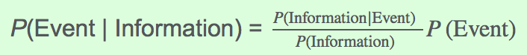

**Economy**

* GDP is not the total income of cititzens (is of households) and not the value of resalable goods (only final).
* Unemployed include frictional unemployment.
* Opportunity cost of A = B/A units of B.
* When the aggregate demand generates inflation, it first affects commodities (like in demand-pull inflation).
* OMA will reduce bank reserves. Why?
* Check 42 again, arbitrage.
* Duplication of lines and supply constarints lead to diseconomies.
* Tight fiscal policy = less government expenditures.

**Financial reporting**

* Memorize the important qualities of financial reporting. Learn which only enhance the usefulness.
* Impairment does not affect cash flow at all.
* Remaining asset live = NBV/Dep expense.
* Impairment: IFRS the asset is compared to the recoverable amount (higher between value in use and fair value – cost to sell). US GAAP is compare only to the undiscounted expected cash flows.
* Custom product are likely to use specific identification.
* Cash ratio includes marketable securities, quick ratio includes marketable securities and receivables.
* IFRS does not specify an order between current and non-current while US GAAP does.
* Question 59 -> check how are bonds amortized and registered under IFRS.
* Evaluation, discussion and presentation of inherent risks in an investment is appropriate in the develop and communicate conclusions/recommendations step.
* deferred tax liability is equal to the tax rate × temporary difference between the carrying amount of the asset and the tax base.
* Declining methods applies the rate to the carrying value, not the original value.
* Expenses = Rev – Exp
* Sources of liquidity. Pirmary: cash in banks, short-term funds, cash flow management. Secondary: Renegotiate debt contracts, liquidating assets, filing for bankruptcy.
* 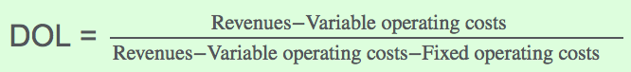
* Operating cycle = Inventory + receivables.

**Corporate finance:**

* Flotation costs should be included in the initial investment.
* Governance best practices include linking compensation with long term objectives.
* A higher risk aversion coefficient means less tolerance to risk.
* Insurance companies are more conservative and need liquidity. Defined-benefit pension plans and charitable foundations have higher tolerance and lower needs.
* ME QUEDE EN LA 80